Queue in Python DSA

1. What is a Queue?
A Queue is a linear data structure that follows the FIFO (First In First Out) principle.
Think of people standing in a ticket line.
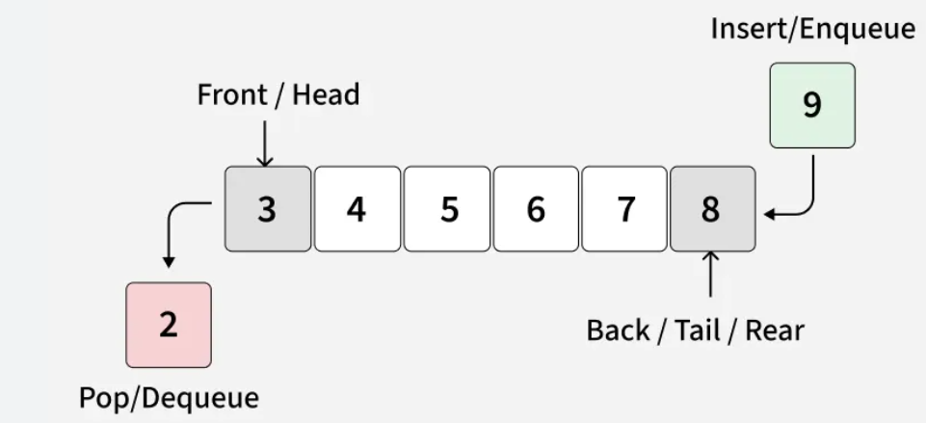

Why not use Python List
queue = []
queue.append(10)
queue.append(20)
queue.append(30)
queue.pop(0)
Looks fine. But... queue.pop(0)removes first element.
Python shifts every remaining element.
Before - 10 20 30 40 50
After - 20 30 40 50

Everything shifts left.
Time Complexity - O(n) which is very slow

Queue Syntax instead of list
Create Queue
from collections import deque
q = deque()
Insert
q.append(10)
q.append(20)
q.append(30)
Remove
q.popleft()
Front
q[0]
Rear
q[-1]
Length
len(q)
Empty
if not q:

Queue Implementation

from collections import deque

q = deque()

q.append(1)
q.append(2)
q.append(3)

print(q)

print(q.popleft())

print(q)

Types of Queue

Normal Queue

Circular Queue

Priority Queue

Double Ended Queue

Breadth First Search (BFS)
BFS (Breadth-First Search) is one of the most important algorithms in DSA and is almost always implemented using a Queue.BFS Code
from collections import deque
queue = deque([root])
while queue:
node = queue.popleft()
if node.left:
queue.append(node.left)
if node.right:
queue.append(node.right)

